**A2141-Asia-Indo Scythian-Pendant-Reindeer- Bronze-1000 CE**

** **

**Figs. 1-2. Asia-Indo Scythian-Pendant-Reindeer- Bronze-1000 CE**

**Case no.: 4**

**Accession Number: A2141**

**Formal Label: Asia-Indo Scythian-Pendant-Reindeer- Bronze-1000 CE**

**Display Description:**

This bronze pendant of a reindeer suggests that it was a symbol of a herd that was managed by the bronze artist. The detailing of the diagnostic palmate brow tines that extend forward, over the face, the pitted coat and the hoofs with dew claws suggests a person with intimate knowledge of the animal.

In the first half of the period stretching from the 8th century BCE to the time of the Roman conquest, the lands to the east of the River Danube became part of the eastern steppe-culture area. Relics characteristic of these centuries are Scythian at a time that Transdanubia became home to people belonging to the Central European Hallstatt culture. In the fourth century BCE, the entire Carpathian Basin of present-day Hungary was invaded by the Celts, the only people to arrive in the Carpathian Basin from the west during this period. A small bronze sculpture of a wild boar found at Báta testifies to the developed nature of their bronze smiths’ art.

[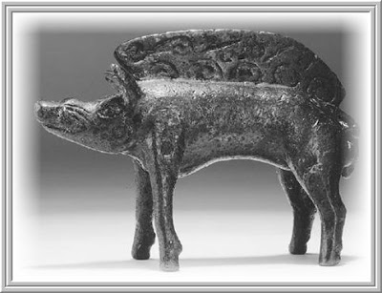](http://3.bp.blogspot.com/-6i1ecz7V-Fw/UHs4C0CcmXI/AAAAAAAASFc/7OS75oBwCNs/s1600/Celts+Bronze+statuette+of+a+pig,+B%C3%A1ta.jpg)

Wild boar bronze figurine found at Báta

Animal husbandry was well established by the European Iron Age. Two major cultural influences in the barbarian world merged with classical Mediterranean tradition in the Carpathian basin. Areas west of the Danube had close ties with the rest of Europe, most directly with the Hallstatt culture (type site: Austria), extending to Britain between the ninth and fifth centuries B.C. Celtic tribes expanded from their homeland in northern France and southern Germany toward southern Europe and Asia Minor as well as the British Isles between the eighth and third centuries B.C. Meanwhile, the Great Hungarian Plain east of the Danube fell under the influence of pre-Scythian and Scythian cultures from the northern Pontic (Black Sea) region during the Early Iron Age (late seventh century B.C.). From the first century A.D. waves of additional migrations lashed the eastern frontiers of Europe.  
Celtic influences met Scythian tradition in the barbarian world of central Europe. Classicism, represented by ancient Greek, Hellenistic, and Roman cultures, flanked these geopolitical developments from the south. Records on animal husbandry originate from the latter, Mediterranean/Pontic, region. Beginning with the description by the Greek historian Herodotus (in the fifth century B.C.) of ferocious “Scythian nomads” of the steppe, classical stereotypes of mobile pastoralists were recycled and homogenized throughout antiquity. Meanwhile, advanced Roman animal breeding is reflected in seminal works by Marcus Terentius Varro, Pliny the Elder, and Columella (first century B.C. to the first century A.D.)  
Most differences between the Celtic, Mediterranean, and steppe types of animal husbandry were rooted in their respective geographical environments. Prehistoric agriculture had reached northcentral and western Europe millennia earlier across the Balkans. Natural habitats in Mediterranean Europe favored the early establishment of cereal cultivation, viticulture, and the keeping of cattle as well as sheep and goats. People in the Celtic homeland (similarly to northern Germanic tribes inhabiting neighboring areas) had long relied on hunting and pigs, ubiquitous in cool and humid forest regions. Steppe peoples adapted to vast, continental plains by developing mobile pastoralism, with little reliance on cultivation and an emphasis on sheep and goat keeping. Their horses also were used for a great variety of purposes. Animal keeping, however, should not be viewed with rigid environmental determinism. As empires expanded and reached various areas and people moved around, their traditions blended and interacted, so that by the Iron Age all the important domestic animals were kept in these three cultural regions.

Scythian tribes included both equestrian nomads and sedentary agriculturalists who inhabited the Eurasian steppe north of the Black Sea. Characteristic of their culture were kurgans (burial mounds), many of them in the Dnieper River region, in which Scythian leaders were interred with grave goods of legendary richness, including dozens of horses. Treasures recovered from these graves are decorated with animal motifs showing Greek and Persian influences. Mythical creatures and hunting scenes dominate this artwork, although the evidence for hunting is scarce among the mundane archaeozoological finds.  
Scythian settlements between the Dnieper and the Volga region had an overwhelming dominance of domesticates. Sometimes animal husbandry also is represented on precious metal objects. Most famous are the horse-catching scenes on the fourth century B.C. gilded silver amphora from Chertomlyk (near the Dnieper River in the Ukraine) and animals on the gold pectoral from Tolstaya Mogila (some 10 kilometers from Chertomlyk). The latter piece weighs more than a kilogram and has a diameter of more than 30 centimeters. Composed of three excentric circles (joined with the clasp in the back), the outer band of the pectoral is decorated with mythical and wild creatures from griffins to locusts. Separated by a band of floral ornaments, the third, inner band documents the domestic sphere of life. Two Scythians in the center sew a piece of sheepskin, while another milks a ewe. Stylistically, it is likely that a Greek goldsmith in a colonial town in the northern Pontic region made this piece sometime in the fourth century B.C The figures look Scythian, but it is difficult to tell whether the wild/domestic dichotomy reflects western or eastern traditions. In a less spectacular form, artifacts decorated in animal style also are known from areas occupied by Scythians in eastern Hungary. Their animal husbandry in the Carpathian Basin can be reconstructed from bone finds at a few rural settlements. In addition to remains of small-bodied cattle, a relatively large number of horse bones (including those of very young foals) occur among the food refuse. The bony cores of large goat horns also point to the eastern pastoral tradition of these communities. A chariot grave with two horses, found at Szentes-Vekerzug on the Great Hungarian Plain, reflects the importance of these animals in all spheres of life. Having defeated the Scythians in the Pontic region, Iranian-speaking Sarmatian pastoralists reached the Carpathian Basin during the first century A.D., approximately at the time the Romans conquered Celtic areas in its western half, estabshing the province of Pannonia. With their westward expansion blocked, Sarmatians and other barbarian tribes spent four centuries in the shadow of the Roman Empire, often in shifting, short-term alliances.  
This probably strengthened their ethnocultural identity, preserving their eastern pastoral tradition. Small relative frequencies of bones from pig and poultry illustrate this conservative tendency. Although in environmental terms the Great Hungarian Plain represents the westernmost section of the Eurasian steppe, it is far too small for long-distance, nomadic herding. To many steppe peoples who ended up there, it represented a dead end in terms of long-range, annual migrations. Mobility of livestock became less of a priority. Various written references to the importance of Sarmatian cavalry are in agreement with the high ratio of horse remains in the food refuse at Sarmatian rural sites. (Among these references are those to the mastering by Germanic Quadi of Sarmatian cavalry tactics, a notation of eight thousand Sarmatian horsemen demanded by the Roman Empire following a defeat in A.D. 175, and the delivery of two thousand mounted warriors to the Romans by the defeated alliance of Sarmatians and Germanic Vandals/Suebians in A.D. 270.) Steppe rituals associated with horses are evidenced by intact horse skulls found at various settlements. It seems that in peacetime Sarmatians traded livestock and animal products with Roman provinces, in exchange for high-quality Roman craft products (e.g., stamped ware and glass). Sarmatian cattle bones look small and nondistinct. Giant horn cores of rams, however, are indicative of impressive individuals in the sheep flocks. It is difficult to tell whether these animals originated from steppe stocks or represent improved Roman “breeds,” adopted by these skillful pastoralists.  
  
**POST-ROMAN DEVELOPMENTS**

As hordes of Germanic and Asiatic barbarians brought down the Roman Empire in the fifth century A.D., warhorses again best represented barbarian animal husbandry. Mounted warriors literally spearheaded these migrations, in keeping with the tactical necessities of migration through hostile areas. Flavius Vegetius Renatus, in his veterinary handbook on horses, wrote that Hun horses “have large heads . . . with no fat at all on the rump. . . . The leanness of the horses is striking. . . . Their ugly appearance . . . is set off by their fine qualities: sober nature, cleverness and their ability to endure any injury.” Note the striking difference between this description, and the coeval, idealized picture of a royal mount from the steppe region. Between A.D. 567 and 804 Asiatic Avars occupied the Carpathian Basin, creating an ethnically heterogeneous empire, including the ruins of Roman Pannonia. The custom of burying warriors with their horses has preserved hundreds of complete horse skeletons for study. Most were stallions or geldings, more lightly built than modern ponies, on average 135 centimeters tall at the withers. They probably represent animals selected by the practical necessities of light cavalry. Avar warriors introduced stirrups to Europe, which, together with saddles with high pommels, helped mounted archers rise and fire their short reflex bows in almost any direction. The composition of food refuse from early Avar settlements often resembles that of the Sarmatians, but the growing contribution of pig and poultry over time in grave goods may indicate an increasingly sedentary lifestyle. In comparison with Slavic settlements, Avar period animal bone assemblages look definitely more nomadic. A summary of animal bone percentages from numerous sites of the seventh to ninth centuries, representing various cultures, shows that the significance of horsemeat decreased in an eastward direction across the steppe. Pork was hardly eaten in the east but was important in sedentary Slavic cultures. Beef and mutton show a less consistent pattern. The next migrants from the steppe, the Magyars, conquered the Carpathian Basin in about A.D. 895. They waged ruthless equestrian raids, rooted in their mobile pastoralist tradition, into much of civilized Europe for more than fifty years. The horse heads and feet buried in some of their graves probably come from skinned animals. Magyar horses therefore are more difficult to reconstruct than their Avar counterparts, to which they are similar in appearance. This does not mean that the two stocks were related, but they probably were shaped by similar military needs.  
Early Magyar meat consumption focused on beef and mutton, with an unusually high average proportion of horsemeat. Pope Gregory III banned hippophagy (horse-eating) in Europe in the eighth century, as Germanic tribes were converted to Christianity. As Magyars established a Christian kingdom in Hungary (A.D. 1000), horse eating gradually declined. Pork also started contributing more to the diet, as it had with the Sarmatians and Avars. Because Magyars (i.e., Hungarians) survived in the Carpathian Basin, there is much speculation about the genetic continuity of their modern domesticates. A mythical animal of the conquering Magyars was, supposedly, a breed of longhorn cattle, which is today called the Hungarian gray. It is reminiscent of the Marreman breed in Italy, which is said to have been introduced by the Huns. This historical confusion is exacerbated by skull finds showing that all peoples of steppe origin (Sarmatians, Avars, and Magyars) kept small, short-horned cattle. Archaeological evidence for long-horned animals comes centuries later in the wake of the Middle Ages. Many pastoral communities kept large guard dogs. The striking similarity between a skull from the period of the Magyar conquest (ninth century) and a modern Hungarian Kuvasz, however, is rooted more in function than genetic continuity. Owing to their high reproductive rates, dog breeds can change especially rapidly.

Scythia was a region of Central Eurasia in classical antiquity, occupied by the Eastern Iranian Scythians, encompassing parts of Eastern Europe east of the Vistula River and Central Asia, with the eastern edges of the region vaguely defined by the Greeks. The Ancient Greeks gave the name Scythia (or Great Scythia) to all the lands north-east of Europe and the northern coast of the Black Sea.  The Scythians – the Greeks' name for this initially nomadic people – inhabited Scythia from at least the 11th century BC to the 2nd century AD. Its location and extent varied over time but usually extended farther to the west than is indicated on the map opposite.

  Scythia was a loose state that originated as early as 8th century BC. Little is known of them and their rulers. The most detailed western description is by Herodotus, though it is uncertain he ever went to Scythia. He says the Scythians' own name for themselves was "Scoloti". The Scythians became increasingly settled and wealthy on their western frontier with Greco-Roman civilization.The region known to classical authors as Scythia included the Pontic-Caspian steppe: Ukraine, southern Russia, and western Kazakhstan (inhabited by Scythians from at least the 8th century BC).

  Genetic evidence for ranging clear across the plains (steppes) from Black Sea to Lake Baikal. The Kazakh steppe: northern Kazakhstan and the adjacent portions of Russia Sarmatia, corresponding to eastern Poland, Ukraine, southwestern Russia, and the northeastern Balkans, ranging from the Vistula River in the west to the mouth of the Danube, and eastward to the Volga Saka tigrakhauda, corresponding to parts of Central Asia, including Kyrgyzstan, southeastern Kazakhstan, and the Tarim Basin Sistan or Sakastan, corresponding to southern Afghanistan, eastern Iran, and southwestern Pakistan, extending from the Sistan Basin to the Indus River.

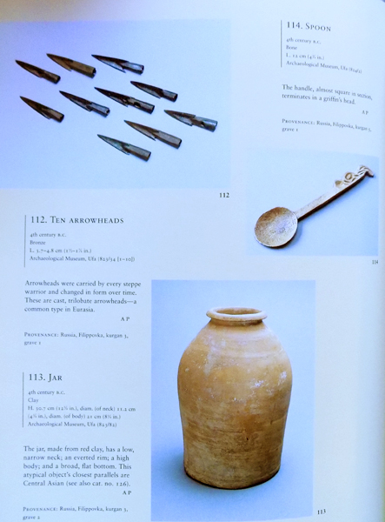

  Following successive invasions of the Indo-Greek kingdoms, the Indo-Scythians also expanded east, capturing territory in what is today the Punjab region. Parama Kamboja, corresponding to northern Afghanistan and parts of Tajikistan and Uzbekistan Alania, corresponding to the northern Caucasus region Scythia Minor, corresponding to the lower Danube river area west of the Black Sea, with a part in Romania and a part in Bulgaria.

    In the 7th century BC Scythians penetrated from the territories north of the Black Sea across the Caucasus. The early Scythian kingdoms were dominated by inter-ethnic forms of dependency based on subjugation of agricultural populations in eastern South Caucasia, plunder and taxes (occasionally, as far as Syria), regular tribute (Media), tribute disguised as gifts (Egypt), and possibly also payments for military support (Assyria).

  It is possible that the same dynasty ruled in Scythia during most of its history. The name of Koloksai, a legendary founder of a royal dynasty, is mentioned by Alcman in the 7th century BC. Prototi and Madius, Scythian kings in the Near Eastern period of their history, and their successors in the north Pontic steppes belonged to the same dynasty. Herodotus lists five generations of a royal clan that probably reigned at the end of the 7th to 6th centuries BC: prince Anacharsis, Saulius, Idanthyrsus, Gnurus (Гнур (ru)), Lycus and Spargapithes.

  After being defeated and driven from the Near East, in the first half of the 6th century BCE, Scythians had to re-conquer lands north of the Black Sea. In the second half of that century, Scythians succeeded in dominating the agricultural tribes of the forest-steppe and placed them under tribute. As a result, their state was reconstructed with the appearance of the Second Scythian Kingdom which reached its zenith in the 4th century BC.

  Scythia's social development at the end of the 5th century BC and in the 4th century BC was linked to its privileged status of trade with Greeks, its efforts to control this trade, and the consequences partly stemming from these two. Aggressive external policy intensified exploitation of dependent populations and progressed the stratification among the nomadic rulers. Trading with Greeks also stimulated sedentarization processes.

  The proximity of the Greek city-states on the Black Sea coast (Pontic Olbia, Cimmerian Bosporus, Chersonesos, Sindica, Tanais) was a powerful incentive for slavery in the Scythian society, but only in one direction: the sale of slaves to Greeks, instead of use in their economy. Accordingly, the trade became a stimulus for capture of slaves as war spoils in numerous wars.

  The Scythian state reached its greatest extent in the 4th century BC during the reign of Ateas. Isocrates believed that Scythians, and also Thracians and Persians, are "the most able to power, and are the peoples with the greatest might." In the 4th century BC, under king Ateas, the tribune structure of the state was eliminated, and the ruling power became more centralized. The later sources do not mention three basileuses any more. Strabo tells that Ateas ruled over the majority of the North Pontic barbarians.

  Written sources tell that expansion of the Scythian state before the 4th century BC was mainly to the west. In this respect Ateas continued the policy of his predecessors in the 5th century BC. During western expansion, Ateas fought the Triballi. An area of Thrace was subjugated and levied with severe duties. During the 90 year life of Ateas, the Scythians settled firmly in Thrace and became an important factor in political games in the Balkans. At the same time, both the nomadic and agricultural Scythian populations increased along the Dniester river. A war with the Bosporian Kingdom increased Scythian pressure on the Greek cities along the North Pontic littoral.

  Materials from the site near Kamianka-Dniprovska, purportedly the capital of the Ateas’ state, show that metallurgists were free members of the society, even if burdened with imposed obligations. Metallurgy was the most advanced and the only distinct craft speciality among the Scythians. From the story of Polyaenus and Frontin, it follows that in the 4th century BC Scythia had a layer of dependent population, which consisted of impoverished Scythian nomads and local indigenous agricultural tribes, socially deprived, dependent and exploited, who did not participate in the wars, but were engaged in servile agriculture and cattle husbandry.

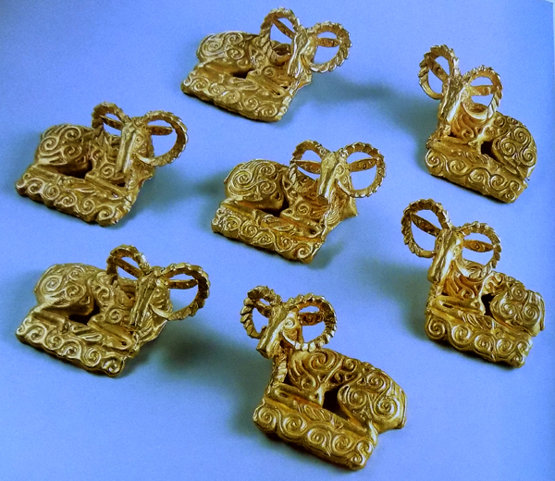

  The year 339 BC was a culminating year for the Second Scythian Kingdom, and the beginning of its decline. The war with Philip II of Macedon ended in a victory by the father of Alexander the Great. The Scythian king Ateas fell in battle well into his nineties. Many royal kurgans (Chertomlyk, Kul-Oba, Aleksandropol, Krasnokut) are dated from after Ateas’s time and previous traditions were continued, and life in the settlements of Western Scythia show that the state survived until the 250s BC. When in 331 BC Zopyrion, Alexander's viceroy in Thrace, "not wishing to sit idle", invaded Scythia and besieged Pontic Olbia, he suffered a crushing defeat from the Scythians and lost his life.

  The fall of the Second Scythian Kingdom came about in the second half of the 3rd century BC under the onslaught of Celts and Thracians from the west and Sarmatians from the east. With their increased forces, the Sarmatians devastated significant parts of Scythia and, "annihilating the defeated, transformed a larger part of the country into a desert".

  The dependent forest-steppe tribes, subjected to exaction burdens, freed themselves at the first opportunity. The Dnieper and Southern Bug populace ruled by the Scythians did not become Scythians. They continued to live their original life, which was alien to Scythian ways. From the 3rd century BC for many centuries the histories of the steppe and forest-steppe zones of North Pontic diverged. The material culture of the populations quickly lost their common features. And in the steppe, reflecting the end of nomad hegemony in Scythian society, the royal kurgans were no longer built. Archeologically, late Scythia appears first of all as a conglomerate of fortified and non-fortified settlements with abutting agricultural zones.

  The development of the Scythian society was marked by the following trends: An intensified settlement process, evidenced by the appearance of numerous kurgan burials in the steppe zone of North Pontic, some of them dated to the end of the 5th century BC, but the majority belonging to the 4th or 3rd centuries BC, reflecting the establishment of permanent pastoral coaching routes and a tendency to semi-nomadic pasturing. The Lower Dnieper area contained mostly unfortified settlements, while in Crimea and Western Scythia the agricultural population grew. The Dnieper settlements developed in what were previously nomadic winter villages, and in uninhabited lands.

  In the 4th century BC in the Dnieper forest-steppe zone, steppe-type burials appear. In addition to the nomadic advance in the north in search of the new pastures, they show an increase of pressure on the farmers of the forest-steppe belt. The Boryspil kurgans belong almost entirely to soldiers and sometimes even women warriors. The bloom of steppe Scythia coincides with decline of forest-steppe. From the second half of the 5th century BC, importing of antique goods to the Middle Dnieper decreased because of the pauperization of the dependent farmers. In the forest-steppe, kurgans of the 4th century BC are poorer than during previous times. At the same time, the cultural influence of the steppe nomads grew. The Senkov kurgans in the Kiev area, left by the local agricultural population, are low and contain poor female and empty male burials, in a striking contrast with the nearby Boryspil kurgans of the same era left by the Scythian conquerors.

  Growth of trade with Northern Black Sea Greek cities, and increase in Hellenization of the Scythian aristocracy. After the defeat of Athens in the Peloponnesian war, Attican agriculture was ruined. Demosthenes wrote that about 400,000 medimns (63,000 tons) of grain was exported annually from the Bosporus to Athens. The Scythian nomadic aristocracy not only served a middleman role, but also actively participated in the trade of grain (produced by dependent farmers as well as slaves), skins and other goods. Scythia's later history is mainly dominated by sedentary agrarian and city elements. As a result of the defeats suffered by Scythians, two separate states were formed, the 'Lesser Scythias': one in Thrace (Dobrudja), and the other in the Crimea and the Lower Dnieper area.

  Having settled this Scythia Minor in Thrace, the former Scythian nomads (or rather their nobility) abandoned their nomadic way of life, retaining their power over the agrarian population. This little polity should be distinguished from the Third Scythian Kingdom in Crimea and Lower Dnieper area, whose inhabitants likewise underwent a massive sedentarization. The interethnic dependence was replaced by developing forms of dependence within the society.

  The enmity of the Third Scythian Kingdom, centred on Scythian Neapolis, towards the Greek settlements of the northern Black Sea steadily increased. The Scythian king apparently regarded the Greek colonies as unnecessary intermediaries in the wheat trade with mainland Greece. Besides, the settling cattlemen were attracted by the Greek agricultural belt in Southern Crimea. The later Scythia was both culturally and socio-economically far less advanced than its Greek neighbors such as Olvia or Chersonesos.

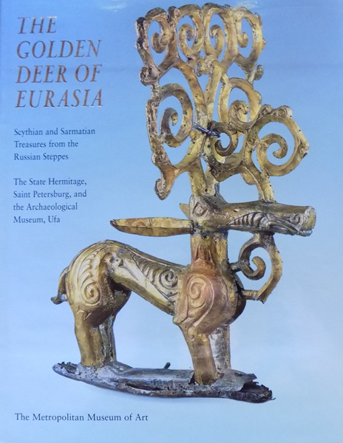

  The continuity of the royal line is less clear in the Lesser Scythias of Crimea and Thrace than it had been previously. In the 2nd century BC, Olvia became a Scythian dependency. That event was marked in the city by minting of coins bearing the name of the Scythian king Skilurus. He was a son of a king and a father of a king, but the relation of his dynasty with the former dynasty is not known. Either Skilurus or his son and successor Palakus were buried in the mausoleum of Scythian Neapol that was used from c. 100 BC to c. 100 AD. However, the last burials are so poor that they do not seem to be royal, indicating a change in the dynasty or royal burials in another place.

  Later, at the end of the 2nd century BC, Olvia was freed from Scythian domination, but became a subject to Mithridates I of Parthia. By the end of the 1st century BC, Olbia, rebuilt after its sack by the Getae, became a dependency of the Dacian barbarian kings, who minted their own coins in the city. Later from the 2nd century AD Olbia belonged to the Roman Empire. Scythia was the first state north of the Black Sea to collapse with the invasion of the Goths in the 2nd century AD (see Oium). At the end of the 2nd century AD, King Sauromates II critically defeated the Scythians and included the Crimea into his Kingdom of the Cimmerian Bosporus, a Roman client state.

  Scythian art is art, primarily decorative objects, such as jewellery, produced by the nomadic tribes in the area known to the ancient Greeks as Scythia, which was centred on the Pontic-Caspian steppe and ranged from modern Kazakhstan to the Baltic coast of modern Poland and to Georgia. The identities of the nomadic peoples of the steppes is often uncertain, and the term "Scythian" should often be taken loosely; the art of nomads much further east than the core Scythian territory exhibits close similarities as well as differences, and terms such as the "Scytho-Siberian world" are often used.

  Other Eurasian nomad peoples recognised by ancient writers, notably Herodotus, include the Massagetae, Sarmatians, and Saka, the last a name from Persian sources, while ancient Chinese sources speak of the Xiongnu or Hsiung-nu. Modern archaeologists recognise, among others, the Pazyryk, Tagar, and Aldy-Bel cultures, with the furthest east of all, the later Ordos culture a little west of Beijing. The art of these peoples is collectively known as steppes art.

  In the case of the Scythians the characteristic art was produced in a period from the 7th to 3rd centuries BC, after which the Scythians were gradually displaced from most of their territory by the Sarmatians, and rich grave deposits cease among the remaining Scythian populations on the Black Sea coast. Over this period many Scythians became sedentary, and involved in trade with neighbouring peoples such as the Greeks.

  In the earlier period Scythian art included very vigorously modelled stylised animal figures, shown singly or in combat, that had a long-lasting and very wide influence on other Eurasian cultures as far apart as China and the European Celts. As the Scythians came in contact with the Greeks at the Western end of their area, their artwork influenced Greek art, and was influenced by it; also many pieces were made by Greek craftsmen for Scythian customers. Although we know that goldsmith work was an important area of Ancient Greek art, very little has survived from the core of the Greek world, and finds from Scythian burials represent the largest group of pieces we now have. The mixture of the two cultures in terms of the background of the artists, the origin of the forms and styles, and the possible history of the objects, gives rise to complex questions.

  Many art historians feel that the Greek and Scythian styles were too far apart for works in a hybrid style to be as successful as those firmly in one style or the other. Other influences from urbanized civilizations such as those of Persia and China, and the mountain cultures of the Caucasus, also affected the art of their nomadic neighbours.  Scythian art especially Scythian gold jewellery is highly valued by museums and many of the most valuable artefacts are in the Hermitage Museum in St Petersburg. Their Eastern neighbours, the Pazyryk culture in Siberia produced similar art, although they related to the Chinese in a way comparable to that of the Scythians with the Greek and Iranian cultures. In recent years, archeologists have made valuable finds in various places within the area.

  The Scythians worked in a wide variety of materials such as gold, wood, leather, bone, bronze, iron, silver and electrum. Clothes and horse-trappings were sewn with small plaques in metal and other materials, and larger ones, including some of the most famous, probably decorated shields or wagons. Wool felt was used for highly decorated clothes, tents and horse-trappings, and an important nomad mounted on his horse in his best outfit must have presented a very colourful and exotic sight. As nomads, the Scythians produced entirely portable objects, to decorate their horses, clothes, tents and wagons, with the exception in some areas of kurgan stelae, stone stelae carved somewhat crudely to depict a human figure, which were probably intended as memorials. Bronze-casting of very high quality is the main metal technique used across the Eurasian steppe, but the Scythians are distinguished by their frequent use of gold at many sites, though large hoards of gold objects have also been found further east, as in the hoard of over 20,000 pieces of "Bactrian Gold" in partly nomadic styles from Tillya Tepe in Afghanistan.  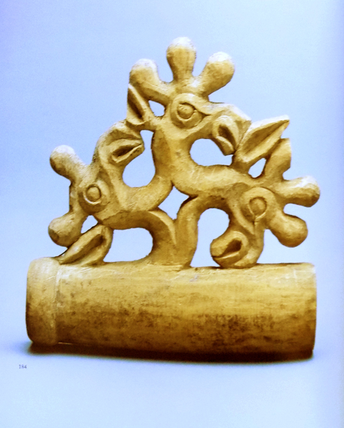

  Earlier pieces reflected animal style traditions; in the later period many pieces, especially in metal, were produced by Greek craftsmen who had adapted Greek styles to the tastes and subject-matter of the wealthy Scythian market, and probably often worked in Scythian territory. Other pieces are thought to be imports from Greece. As the Scythians prospered through trade with the Greeks, they settled down and started farming. They also established permanent settlements such as a site in Belsk, Ukraine believed to the Scythian capital Gelonus with craft workshops and Greek pottery prominent in the ruins.

  The Pazyryk burials (east of Scythia proper) are especially important because the frozen conditions have preserved a wide variety of objects in perishable materials that have not survived in most ancient burials, on the steppes or elsewhere. These include wood carvings, textiles including clothes and felt appliqué wall hangings, and even elaborate tattoos on the body of the so-called Siberian Ice Maiden. These make it clear that important ancient nomads and their horses, tents, and wagons were very elaborately fitted out in a variety of materials, many brightly coloured. Their iconography includes animals, monsters and anthropomorphic beasts, and probably some deities including a "Great Goddess", as well as energetic geometric motifs.

  Archaeologists have uncovered felt rugs as well as well-crafted tools and domestic utensils. Clothing uncovered by archaeologists has also been well made many trimmed by embroidery and appliqué designs. Wealthy people wore clothes covered by gold embossed plaques, but small gold pieces are often found in what seem to be relatively ordinary burials. Imported goods include a famous carpet, the oldest to survive, that was probably made in or around Persia.

  Steppes jewelry features various animals including stags, cats, birds, horses, bears, wolves and mythical beasts. The gold figures of stags in a crouching position with legs tucked beneath its body, head upright and muscles tight to give the impression of speed, are particularly impressive. The "looped" antlers of most figures are a distinctive feature, not found in Chinese images of deer. The species represented has seemed to many scholars to be the reindeer, which was not found in the regions inhabited by the steppes peoples at this period.

  The largest of these were the central ornaments for shields, while others were smaller plaques probably attached to clothing. The stag appears to have had a special significance for the steppes peoples, perhaps as a clan totem. The most notable of these figures include the examples from: the burial site of Kostromskaya in the Kuban dating from the 6th century BC (Hermitage); Tápiószentmárton in Hungary dating from the 5th century BC, now National Museum of Hungary, Budapest; Kul Oba in the Crimea dating from the 4th century BC (Hermitage).

  Another characteristic form is the openwork plaque including a stylized tree over the scene at one side, of which two examples are illustrated here. Later large Greek-made pieces often include a zone showing Scythian men apparently going about their daily business, in scenes more typical of Greek art than nomad-made pieces. Some scholars have attempted to attach narrative meanings to such scenes, but this remains speculative.

  Although gold was widely used by the ruling elite of the various Scythian tribes, the predominant material for the various animal forms was bronze. The bulk of these items were used to decorate horse harness, leather belts & personal clothing. In some cases these bronze animal figures when sewn onto stiff leather jerkins & belts, helped to act as armor.

  The use of the animal form went further than just ornament, these seemingly imbuing the owner of the item with similar prowess & powers of the animal which was depicted. Thus the use of these forms extended onto the accoutrements of warfare, be they swords, daggers, scabbards, or axes.

  The primary weapon of this horse riding culture was the bow, & a special case had been developed to carry the delicate but very powerful composite bow. This case, "the gorytus", had a separate container on the outside which acted as a quiver, & the whole was often decorated with animal scenes or scenes depicting daily life on the steppes. There was a marked following of Grecian elements after the 4th century BC, when Greek craftsmen were commissioned to decorate many of the daily use articles.

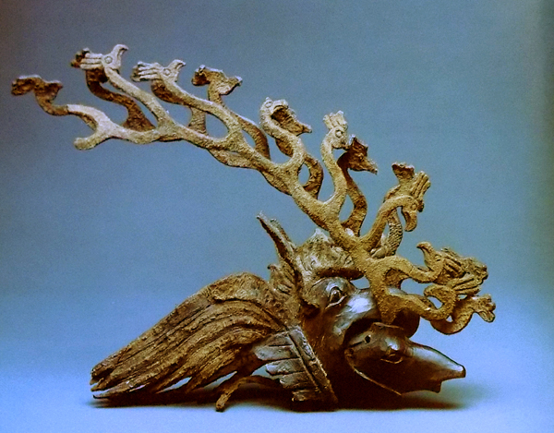

  Scythian art has become well known in the West thanks to a series of touring loan exhibitions from Ukrainian and Russian museums, especially in the 1990s and 2000s. Kurgans are large mounds that are obvious in the landscape and a high proportion have been plundered at various times; many may never have had a permanent population nearby to guard them. To counter this, treasures were sometimes deposited in secret chambers below the floor and elsewhere, which have sometimes avoided detection until the arrival of modern archaeologists, and many of the most outstanding finds come from such chambers in kurgans that had already been partly robbed.

  Elsewhere the desertification of the steppe has brought once-buried small objects to lie on the surface of the eroded land, and many Ordos bronzes seem to have been found in this way. Russian explorers first brought Scythian artworks recovered from Scythian burial mounds to Peter the Great in the early 18th century. These works formed the basis of the collection held by the Hermitage Museum in Saint Petersburg. Catherine the Great was so impressed from the material recovered from the kurgans or burial mounds that she ordered a systematic study be made of the works. However, this was well before the development of modern archaeological techniques.

  Nikolai Veselovsky (1848-1918) was a Russian archaeologist specializing in Central Asia who led many of the most important excavations of kurgans in his day.[11] One of the first sites discovered by modern archaeologists were the kurgans Pazyryk, Ulagan district of the Altay Republic, south of Novosibirsk. The name Pazyryk culture was attached to the finds, five large burial mounds and several smaller ones between 1925 and 1949 opened in 1947 by a Russian archeologist, Sergei Rudenko; Pazyryk is in the Altay Mountains of southern Siberia. The kurgans contained items for use in the afterlife. The famous Pazyryk carpet discovered is the oldest surviving wool pile oriental rug.

  The enormous hoard of "Bactrian gold" discovered at Tillya Tepe in northern Afghanistan in 1978 comes from the fringes of the nomadic world, and the objects reflect the influence of many cultures to the south of the steppes as well as steppes art. The six burials come from the early 1st century AD (a coin of Tiberius is among the finds) and though their cultural context is unfamiliar, it may relate to the Indo-Scythians who had created an empire in north India.

  Recent digs in Belsk, Ukraine uncovered a vast city believed to be the Scythian capital Gelonus described by Herodotus. Numerous craft workshops and works of pottery have been found. A kurgan or burial mound near the village of Ryzhanovka in Ukraine, 75 mi (121 km) south of Kiev, found in the 1990s has revealed one of the few unlooted tombs of a Scythian chieftain, who was ruling in the forest-steppe area of the western fringe of Scythian lands. There at a late date in Scythian culture (c. 250 - 225 BC), a recently nomadic aristocratic class was gradually adopting the agricultural life-style of their subjects. Many items of jewelry were also found in the kurgan.

  A discovery made by Russian and German archaeologists in 2001 near Kyzyl, the capital of the Russian republic of Tuva in Siberia is the earliest of its kind and predates the influence of Greek civilisation. Archaeologists discovered almost 5,000 decorative gold pieces including earrings, pendants and beads. The pieces contain representations of many local animals from the period including panthers, lions, bears and deer. Earlier rich kurgan burials always include a male, with or without a female consort, but from the 4th and 3rd centuries there are number of important burials with only a female.

  The finds from the most important nomad burials remain in the countries where they were found, or at least the capitals of the states in which they were located when found, so that many finds from Ukraine and other countries of the former Soviet Union are in Russia. Western European and American museums have relatively small collections, though there have been exhibitions touring internationally. The Hermitage Museum in St. Petersburg has the longest standing and the best collection of Scythian art. Other museums including several local ones in Russia, in Budapest and Miskolc in Hungary, Kiev in Ukraine, the National Museum of Afghanistan and elsewhere have important holdings. The Scythian Gold exhibition came from a number of Ukrainian exhibitions including the Museum of Historical Treasures of Ukraine, the Institute of Archaeology in Kiev and the State Historical Archaeological Preserve at Pereiaslav-Khmel'nyts'kyi.

LC Classification:

**Date or Time Horizon:** 1000 CE

**Geographical Area:**

Map:

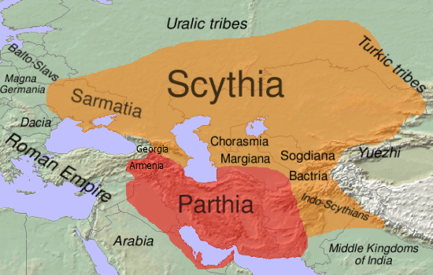

The approximate extent of [Eastern Iranian languages](https://en.wikipedia.org/wiki/Eastern_Iranian_languages) and people in Middle Iranian times in the 1st century BC is shown in orange <https://upload.wikimedia.org/wikipedia/commons/a/ad/Scythia-Parthia_100_BC.png>

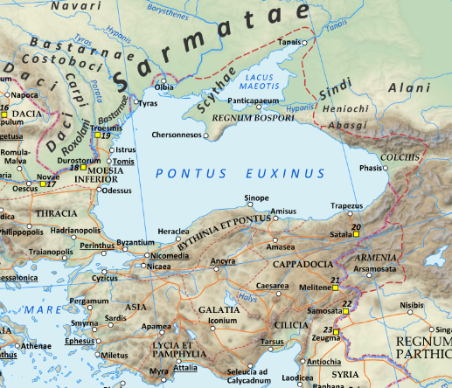

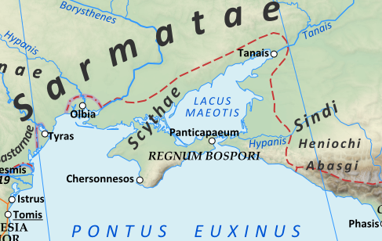

The territory of the Scythae Basilaei ("Royal Scyths") along the north shore of the [Black Sea](https://en.wikipedia.org/wiki/Black_Sea) around 125 AD. By User:Andrein - Own work, CC BY-SA 3.0, <https://commons.wikimedia.org/w/index.php?curid=69253985>

Map of the [Roman Empire](https://en.wikipedia.org/wiki/Roman_Empire) in 125 during the reign of emperor [Hadrian](https://commons.wikimedia.org/wiki/Hadrian), cropped to show the Scythian-ruled coast of the Black Sea. Projection [Lambert azimuthal-equal area](https://en.wikipedia.org/wiki/Lambert_azimuthal_equal-area_projection). Central latitude: 45° N, central longitude: 20° E. X, Y origin offset - 0 Datum: [ETRS89](https://en.wikipedia.org/wiki/ETRS89) Sources The physical map was made using the following public domain sources: Topography: [NASA Shuttle Radar Topography Mission](http://www2.jpl.nasa.gov/srtm) (SRTM30) data Shoreline, lakes and rivers: derived from [Natural Earth](http://www.naturalearthdata.com/downloads/10m-physical-vectors/) data Additional references for the map content: [Tacitus](https://commons.wikimedia.org/w/index.php?title=Tacitus&action=edit&redlink=1), Germania (ca. 100)[Ptolemy](https://commons.wikimedia.org/wiki/Ptolemy), Geographia (ca. 140) Atlante storico DeAgostini, Instituto Geografico DeAgostini, 1998. pg. 35-41. Historischer Weltatlas, Dr. Walter Leisering, Marix Verlag, 2011. pg. 26-27 Történelmi világatlasz, Cartographia Kiadó, 2005. pg. 20-21. The Penguin Historical Atlas of Ancient Rome by Christopher Scarre, Penguin Historical Atlases, 1995. pg. 81. Software used GIS: [Open JUMP GIS](https://en.wikipedia.org/wiki/JUMP_GIS) (open source): <http://www.openjump.org/> [GRASS GIS](https://en.wikipedia.org/wiki/GRASS_GIS) (open source): <http://grass.osgeo.org/> Graphics editors: [Inkscape](https://en.wikipedia.org/wiki/Inkscape) (open source): <http://inkscape.org/> [GIMP](https://en.wikipedia.org/wiki/wiki/GIMP) (open source): <http://www.gimp.org/>

 Map of the [Roman Empire](https://en.wikipedia.org/wiki/Roman_Empire) in 125 during the reign of emperor [Hadrian](https://commons.wikimedia.org/wiki/Hadrian), cropped to show the Scythian-ruled coast of the Black Sea.

The physical map was made using the following public domain sources:

* Topography: [NASA Shuttle Radar Topography Mission](http://www2.jpl.nasa.gov/srtm) (SRTM30) data
* Shoreline, lakes and rivers: derived from [Natural Earth](http://www.naturalearthdata.com/downloads/10m-physical-vectors/) data

Additional references for the map content:

* [Tacitus](https://commons.wikimedia.org/w/index.php?title=Tacitus&action=edit&redlink=1), Germania (ca. 100)
* [Ptolemy](https://commons.wikimedia.org/wiki/Ptolemy), Geographia (ca. 140)
* Atlante storico DeAgostini, Instituto Geografico DeAgostini, 1998. pg. 35-41.
* Historischer Weltatlas, Dr. Walter Leisering, Marix Verlag, 2011. pg. 26-27
* Történelmi világatlasz, Cartographia Kiadó, 2005. pg. 20-21.
* The Penguin Historical Atlas of Ancient Rome by Christopher Scarre, Penguin Historical Atlases, 1995. pg. 81.

GPS coordinates:

**Cultural Affiliation:**

**Media:**

**Dimensions:**

**Weight:**

**Condition:**

**Provenance:**

Discussion:

References: